“Let’s Go Outside” Theme Rubric
Use this Rubric during the beginning, middle, and end of the Unit to see how the student has progressed using the vocabulary and understanding the concepts in Unit 6.
Student______________________________ | Date_________________________________
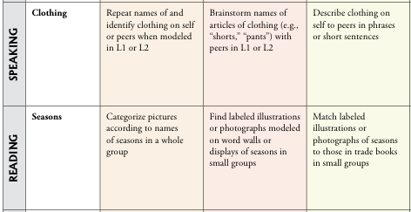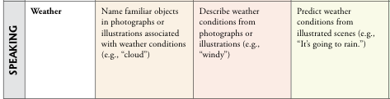
Observations / Needs work on:

